Tamales on Mondays
Easy to heat:
1. Microwave 30-45 seconds
2. Oven - 350 degrees until warm or hot

Who: My spouse, Ricardo, and I making them by hand in our home

What: Tamales are a delicious, tasty and easy-to-reheat food from Latin America.
These are meat tamales that make a meal by themselves. They are made with cooked pork, New Mexican chilies and spices that are mild, but bursting with flavor. These strike a perfect balance of the traditional Mexican kitchen without causing any sweat- just pure deliciousness!
They can be eaten alone or coupled with side dishes like beans and rice.

Where: Brought to you at work/school freshly prepared & packaged EVERY other Monday.
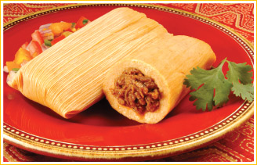

When: Every other Monday

Why: To provide a tasty meal made with love. It’s my father-in-law’s “secret” recipe and my husband really enjoys preparing them.
Cost: $6.50/per half-dozen
$13.00/per dozen
The "Family Pack" of 20 for $20
---------------------------------------------------------------------------------------------------------------------------------
ORDER FORMS
Detach this portion and place (or inter-school mail) in my mailbox- “Porras”
Name: _____________________ Room # during 7th hour: ________

Check one: __ half dozen for $6.50 __ dozen for $13.00 ___ Family Pack 20 for $20

Payment: Attach cash or check please and place this portion of the flyer in the "Porras" box located in the main office.
ORDERS MAY BE PLACED ANY DAY OF THE WEEK.
Delivery date will be promptly email to you (Every other Monday).
Please note that tamale orders can be made at any time with delivery
always being Monday afternoons directly delivered to your classroom door.

